Thomas Jackson
49066, Serjeant T. Jackson, of the 2nd Battalion, the Northumberland Fusiliers, died on at the age of 28 on 23rd October, 1918. He is buried in the Basra War Cemetery.
He was born on 8th December 1889, the son of William and Mary Ellen Jackson, of 10, Shevington Lane, Shevington, and baptised in St Wilfrid’s Church, Standish. He enlisted in Dinnington, Northumberland. This might suggest that he moved to Dinnington to the new pit opened there which was more modern and paid better wages. Richard Hooton also moved to Dinnington. The colliery paid the men £2 to enlist.

Why don’t we know more about Thomas?
Thomas would have had a service record. Sadly, about 70% of service records from World War 1 were destroyed when the Army Records Office in which they were stored in Arnside Street, Walworth, London, was burnt during an air raid in 1940. It would appear that Thomas’s records were lost at that time.
The volunteers who have searched the microfiche of the Wigan Observer over the last four years did not discover a record of his death.
There is no detailed on-line account of the Battle of Sharqat.
However, Thomas’s brother and sisters will have been the grandparents of people alive today in the Wigan area. Can anyone help?
Thomas’s family
In 1901 Thomas was living with his parents, William and Mary Ellen Jackson, at Barracks, White Hill Lane. This was probably connected to White Hill Farm on Shevington Lane, but the house no longer exists. The family might have been living elsewhere before this. On Thomas’s baptism record, his home is given as Shevington Moor.
Then there were four children. Father was a coal miner (hewer); presumably he cut the coal from the coal face.
10 years later the family were living at the bottom of Shevington Lane near the Plough and Harrow. The CWGC website says that they lived at 10, Shevington Lane. There is still a number 10 but it is a new-build. The census, however, says the family lived at Copperas Houses, 12, Shevington Lane, which do not exist any more, but were probably on the site now occupied by the Braithwaite cul-de-sac.
Now there were six children. The two older boys both worked in the mine as hauliers. The eldest girl, Nancy, was a factory hand.
Thomas’s work
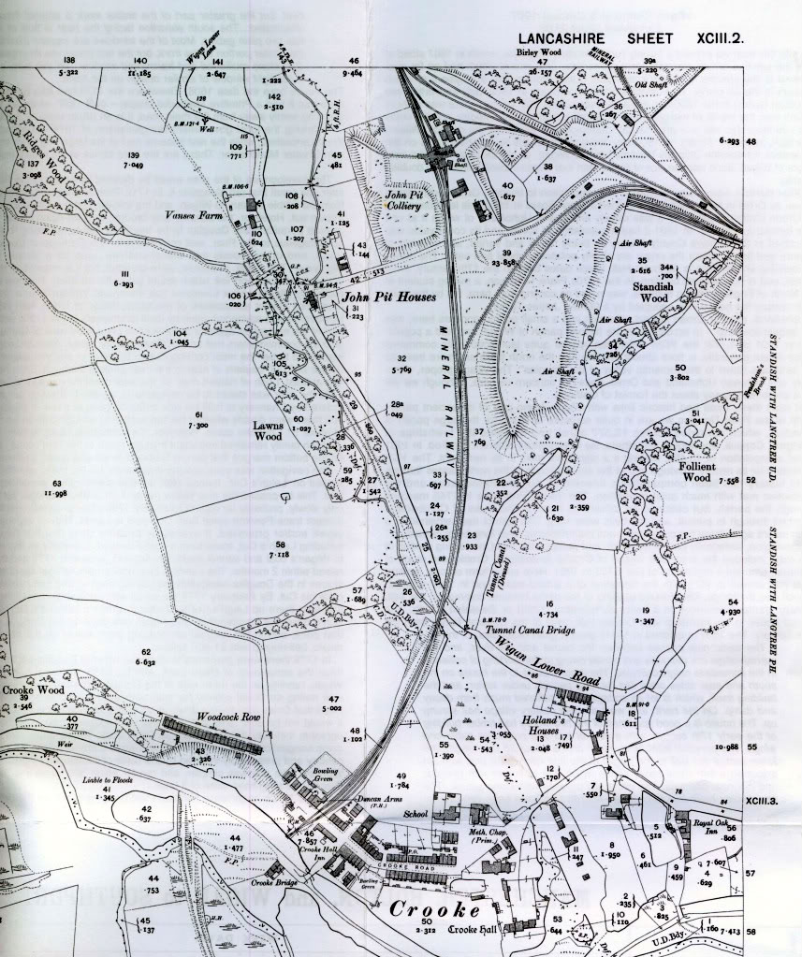

John Pit

We do not know the colliery at which Thomas worked, but he could have walked to John Pit each day from Shevington Village. John Pit was just on the eastern (Standish) side of the bends on Wigan Lower Road
What happened to Thomas?
Thomas probably died at the Battle of Sharqat, 23rd – 30th October, 1918, at which the Turkish army was defeated by the forces of General William Marshall.
Allied forces took action in Palestine and in modern day Iraq, then the geographical area known as Mesopotamia, the land “between the rivers” Tigris and Euphrates. The controlling power in the area was the Ottoman Empire, with its capital at Istanbul, and it stretched from Algeria in the west, as far north as Budapest, as far east as the Black Sea, and as far south as the mouth of the Red Sea. The Ottomans were staunch allies of the Germans. The Ottoman Empire collapsed at the end of World War 1 and the effects of this collapse are still being felt today.
Britain had entered Iraq soon after the declaration of war, partly to protect oil refineries but also to maintain British prestige with Indian Muslim opinion. A large number of Indian troops were involved in the campaign. British troops invaded Mesopotamia and captured Basra in 1914 and for the rest of the war fought their way northwards.
In late1918, anticipating an Ottoman armistice following the defeat of the Ottomans in Palestine and the recent surrender of Bulgaria, British Premier David Lloyd George ordered Sir William Marshall, Commander-in-Chief on the Mesopotamian front, to remove any residual Ottoman presence from that theatre by twin advances up the Euphrates and Tigris rivers, and capture the oil fields near Mosul on the Tigris. Marshall set out on 23rd October, and the Turkish commander surrendered on 30th October – (from Wikipedia).
Since Sharqat is around 700 kilometres north of Basra, Thomas’s body must have been taken there after the war.

